**SESSION 4**

**Git** diff command-

To create file by vim editor :-

$ vim index.txt

Then vim editor is open .Here type the text we want in the file and then

Ctrl+C to go to the last line of vim editor. Then type

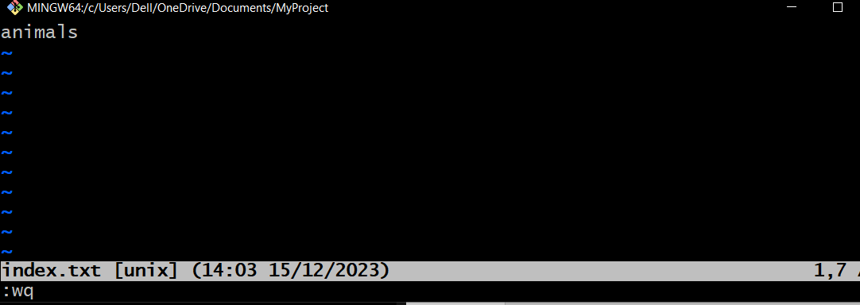:wq and press enter .

( :wq is to save the file and then exit from vim editor.)

After that file is created :-

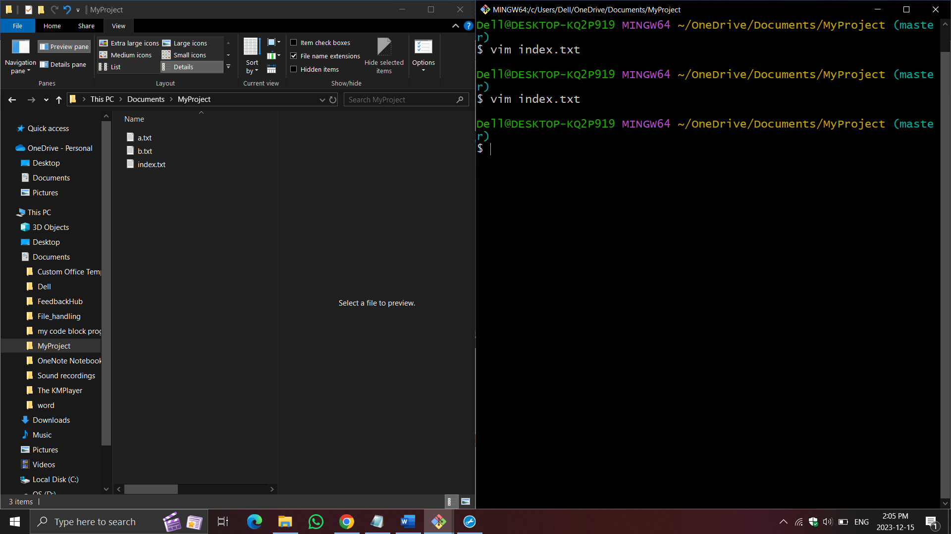

**GIT diff command**

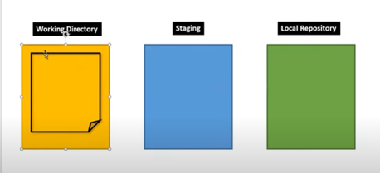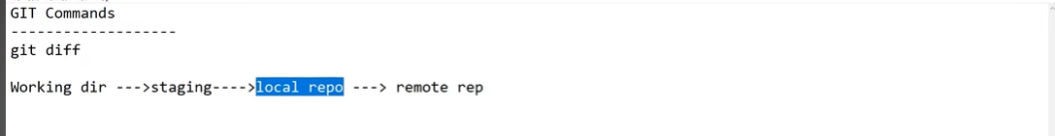

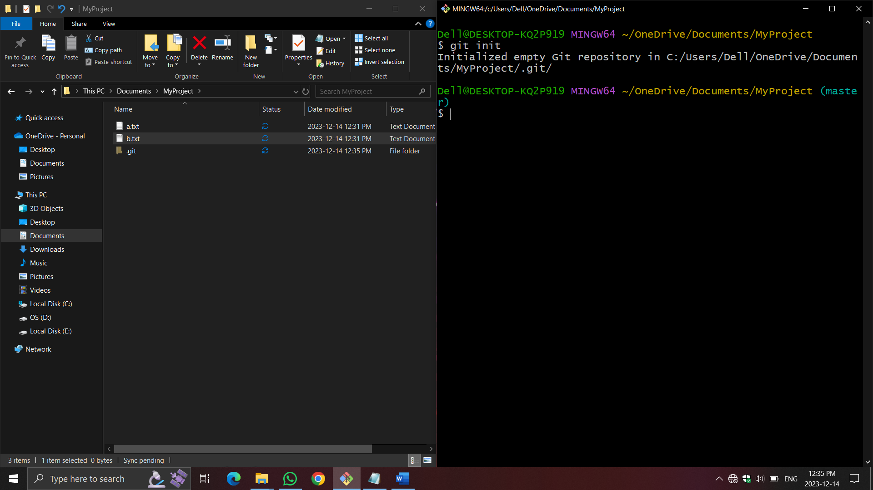Git init command:-

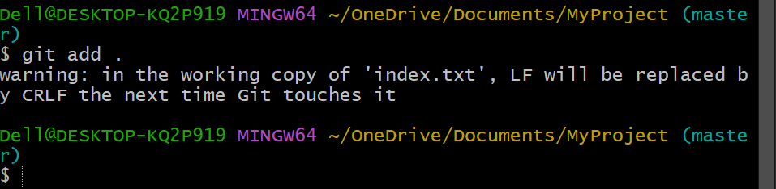Add the files to staging area –

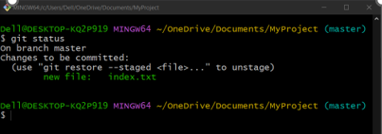Before editing the files –

Now ,

**Requirement 1: To see the difference in file content between the working directory and staging area**

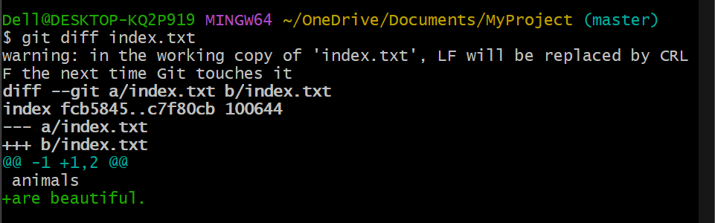$ git diff index.txt

Meaning of the following lines :-

**diff --git a/index.txt b/index.txt**

**index fcb5845..c7f80cb 100644**

**--- a/index.txt**

**+++ b/index.txt**

@@ -1 +1,2 @@

animals

+are beautiful.

-----------------------------------------------------------------------------------

**diff --git a/index.txt b/index.txt**

a/index.txt 🡪 represents source (staging area)

b/index.txt 🡪 represents destination (working directory)

**index fcb5845..c7f80cb 100644**

fcb5845 🡪 Hash of the file content from source/staging

c7f80cb 🡪 Hash of the content from destination/workspace

100644 🡪 git file mode

100 – represents type of the file

644 – File permissions rw-r-r (6-4-4)

4 – r

2 – w

1 – e

Where , r – read permission , w – write permission , e – execute permission , rw - read-write permission

**--- a/index.txt 🡪** source file missing some lines (staging area)

**+++ b/index.txt 🡪** New lines added in destination file (working directory)

@@ -1 +1,2 @@

-1 means one line missing from source file

+1 means one line added to the destination file

+2 means there a total 2 lines in the main or destination file

animals

+are beautiful.

1. If any line prefixed with space means it is unchanged.
2. If any line prefixed with + means it is added in the destination copy.
3. If any line prefixed with – means it is removed from the destination copy.

Now ,

**Requirement 2 : To see the File Content between working directory and last commit**

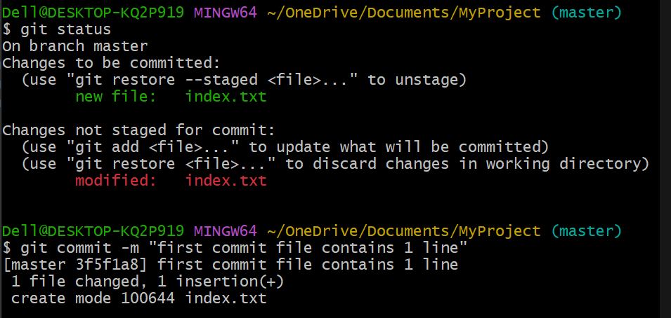If not commited then commit first

Then , go to the vim editor and write some more lines and save it.

Then to see the difference between local repository and last commit run the command

* Last commit refered using HEAD

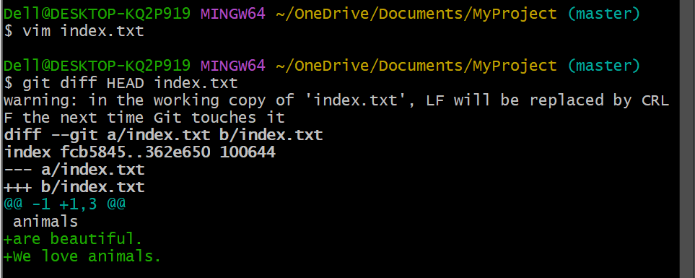

**Requirement 3 :- To see the difference in File content between Staging Copy and Last Commit**

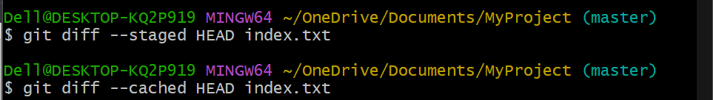

**Requirement 4 :- To see the difference in File Content between specific Commit and Working Directory Copy**

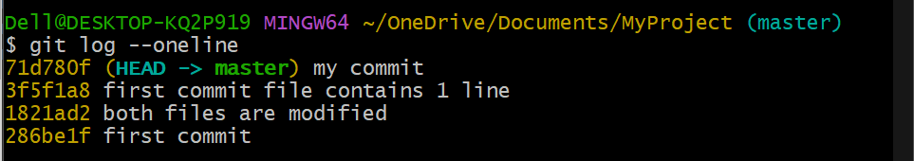$ git log –oneline

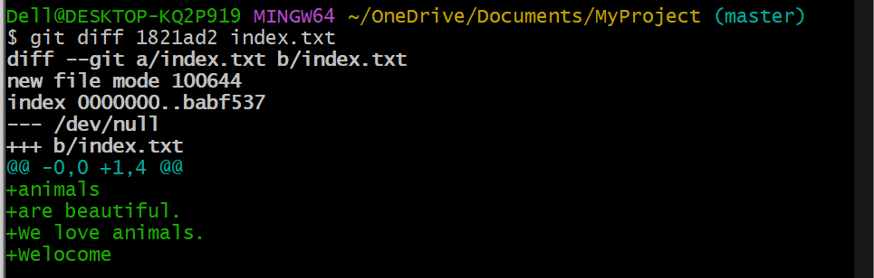$ git diff 1821ad2 index.txt means (git diff ‘commit id ‘ index.txt)

**Requirement 5 :- To see the difference in File content between specific commit and staging area copy**

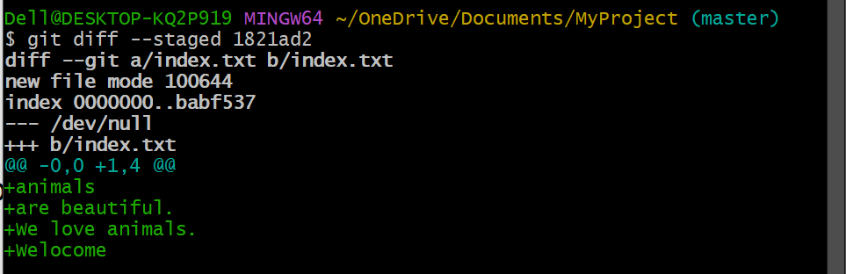$ git diff --staged 1821ad2

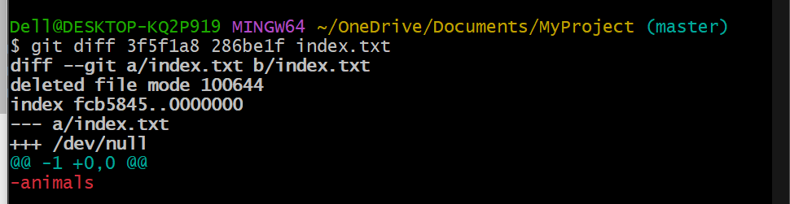**Requirement 6 :- To see the difference in File content between 2 specific commits**

**Requirement 7 :- To see the difference in Content between two branches**

master branch

main branch

$ git diff master main --> It show all the difference between master branch and main branch

**Requirement 8 :- To see the difference in contents between Local and Remote Repositories**

$ git diff master origin/master

Where origin always represents the remote repository